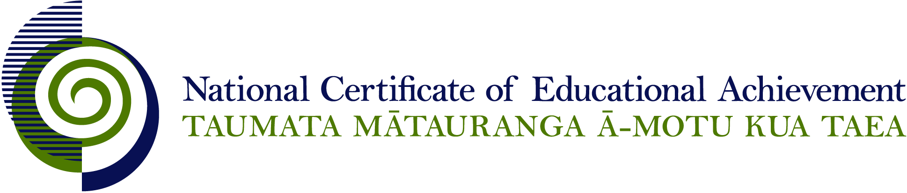

NCEA Level 1 Drama

Conditions of Assessment
EXPIRED

General Information

Subject Reference | Drama
Domain | Drama Performance
Level | 1

This document provides guidelines for assessment against internally assessed standards. Guidance is provided on:
- appropriate ways of, and conditions for, gathering evidence
- ensuring that evidence is authentic
- any other relevant advice specific to an achievement standard.

NB: It is expected that teachers are familiar with additional generic guidance on assessment practice in schools published on the NZQA website. This should be read in conjunction with these Conditions of Assessment.

For All Standards

Internal assessment provides considerable flexibility in the collection of evidence. Evidence can be collected in different ways to suit a range of teaching and learning styles and a range of contexts of teaching and learning. Care needs to be taken to allow students opportunities to present their best evidence against the standard(s) that are free from unnecessary constraints.

It is recommended that the design of assessment reflects and reinforces the ways students have been learning. Collection of evidence for the internally assessed standards could include, but is not restricted to, an extended task, an investigation, digital evidence (such as recorded interviews, blogs, photographs or film) or a portfolio of evidence.

It is also recommended that the collection of evidence for internally assessed standards should not use the same method that is used for any external standards in a programme/course, particularly if that method is using a time bound written examination. This could unfairly disadvantage students who do not perform well under these conditions.

A separate assessment event is not needed for each standard. Often assessment can be integrated into one activity that collects evidence towards two or three different standards from a programme of learning. Evidence can also be collected over time from a range of linked activities (for example, in a portfolio).This approach can also ease the assessment workload for both students and teachers.

Effective assessment should suit the nature of the learning being assessed, provide opportunities to meet the diverse needs of all students and be valid and fair.

Where manageable, and after further learning has taken place, students may be offered a maximum of one further opportunity for assessment against an assessment standard within a year.

Authenticity of student evidence needs to be assured regardless of the method of collecting evidence. This needs to be in line with school policy. For example, for an investigation carried out over several sessions, this could include teacher observations or the use of milestones such as meetings with students, journal or photographic entries recording progress etc.

Specific Information for Individual Internal Achievement Standards

Achievement Standard Number | 90006 Drama 1.1
Title | Apply drama techniques in a dramatic context
Number of Credits | 4
Version | 6

The standard requires students to provide an annotated script and supporting material. While this material is necessary for achievement, it does not constitute evidence to support attainment of higher levels of achievement. Supporting evidence can be presented in oral, electronic, or paper based formats.

At all times the primary focus of the assessment is the performance. Supporting evidence serves to support and clarify the student’s understanding and their intentions for performance.

The performance should be 2 – 4 minutes long.

It may not be appropriate to provide a reassessment opportunity for this standard.

Achievement Standard Number | 90997 Drama 1.2
Title | Devise and perform a drama
Number of Credits | 5
Version | 2

At all times the primary focus of the assessment is the devising and performing. Devising requires active participation in the creative processes by all members of the group.

The standard requires students to provide a brief supporting statement. This evidence can be presented in oral, electronic, or paper based formats.

The supporting material serves to clarify the purpose for the drama, and could assist the teacher when making assessment decisions. The teacher needs to verify the individual participation in the devising process. While this participation and supporting material are necessary for achievement, it does not constitute evidence to support attainment for higher levels of achievement.

Groups should be between 3 - 5 students.

The devised drama should be between 6 – 8 minutes depending on the size of the group. It is suggested that approximately 2 minutes per student is appropriate for assessment at this level.

It may not be appropriate to offer reassessment opportunities for this standard.

Achievement Standard Number | 90999 Drama 1.4
Title | Use features of a drama/theatre form in a performance
Number of Credits | 4
Version | 3

The standard requires students to provide supporting material which may or may not include an annotated text. While a statement of intent and a list of features used are necessary for achievement, it does not constitute evidence to support attainment for higher levels of achievement. This evidence can be presented in oral, electronic, or paper based formats.

At all times the primary focus of the assessment is the performance. The supporting material serves to support and clarify the student’s understanding and their intentions for performance.

Although students may perform in a group the performances are assessed individually.

Achievement Standard Number | 91000 Drama 1.5
Title | Demonstrate understanding of a significant play
Number of Credits | 4
Version | 3

The assessment evidence must be completed and assessed individually. However the exploration of the work could be group based.

Evidence is to be based on practical presentation.

This could take the form of any of, or a combination of, the following:
- seminar with accompanying notes
- PowerPoint accompanied by an oral explanation
- in-role presentation with accompanying notes
- wall chart accompanied by an oral explanation.

It may not be appropriate to offer reassessment opportunities for this standard.

Achievement Standard Number | 90009 Drama 1.6
Title | Perform an acting role in a scripted production
Number of Credits | 5
Version | 6

The standard requires students to provide an annotated script. While this is necessary for achievement, it does not constitute evidence to support attainment of higher levels of achievement. This evidence can be presented in oral, electronic, or paper based formats.

At all times the primary focus of the assessment is the performance. The annotated script serves to clarify and support the student’s understanding and their intentions for performance.

A script for 2 students should be approximately 6-10 minutes long, for 3-4 students 7-15 minutes long, and for 5 students 10-20 minutes long.

Although the students will work in a group they will be assessed individually.

It may not be appropriate to offer reassessment opportunities for this standard.

